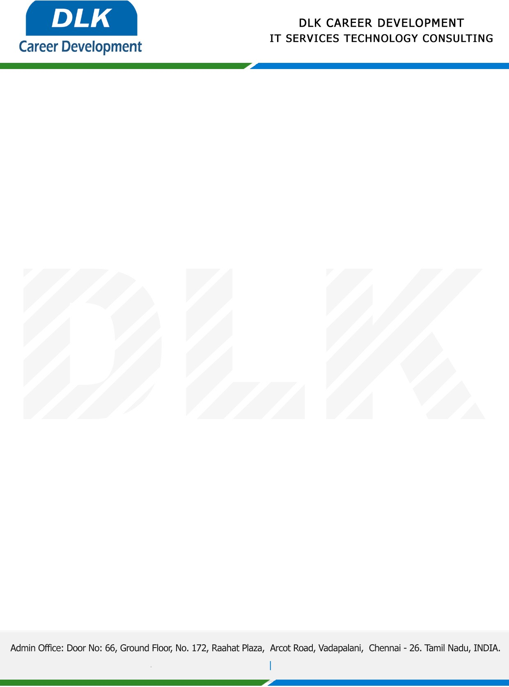

**Date: 02/ May /2023**

**SUB: PROJECT COMPLETION CERTIFICATE**

This is to certify that **MR AKASH S (REG NO:311519104007) BE- Computer Science and Engineering,** final year student **Meenakshi Sundararajan Engineering College, Chennai** has Successfully Completed the Project Work under the domain of “**IOT”** in our organization during the Period **(01st February 2023** to **30th April 2023).**

**Topic:** Controlling Smart Appliances using Augmented Reality.

We appreciate your interest in **DLK CAREER DEVELOPMENT**

**“Best Wishes for Your Future Endeavors “**

For **DLK CAREER DEVELOPMENT**

**HR Manager**

**VELMURUGAN J**